How to find your Athletics Hub URN and password

If you have previously logged into uLearn or My Athletics Portal, your Athletics Hub login details will be the same.

How to find your URN

- Go to www.athleticshub.co.uk and click on the ‘Forgot your URN?’ link

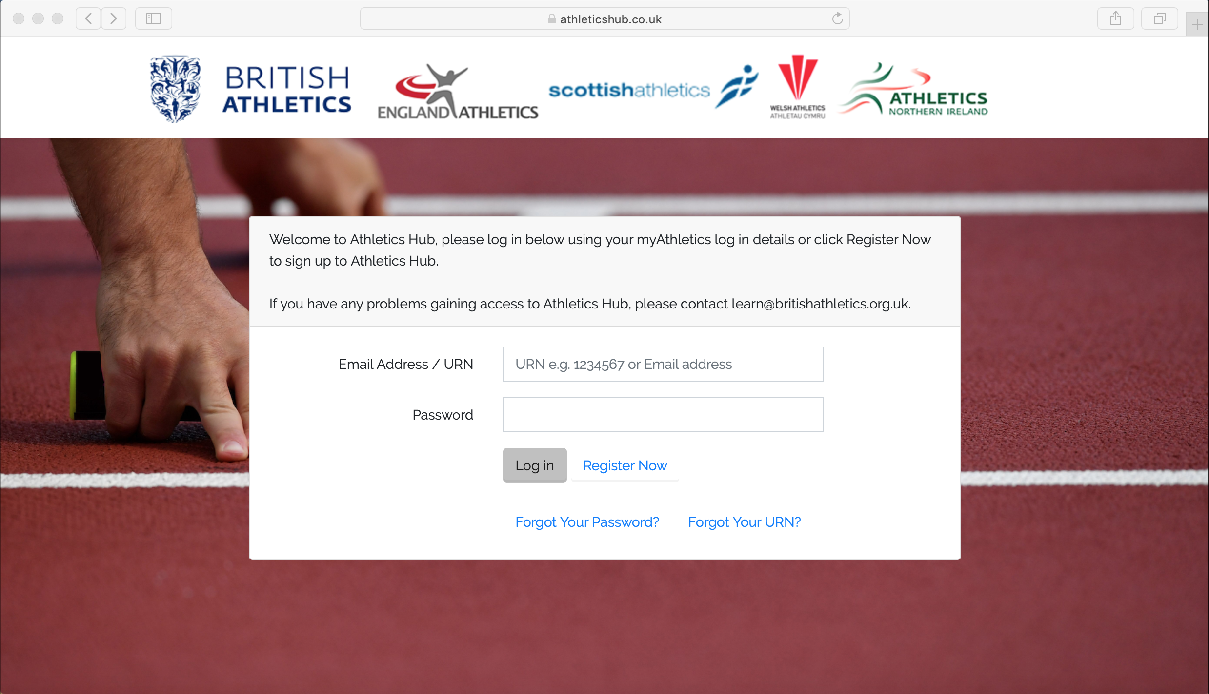

- Enter your Date of Birth, and name and click ‘Next’
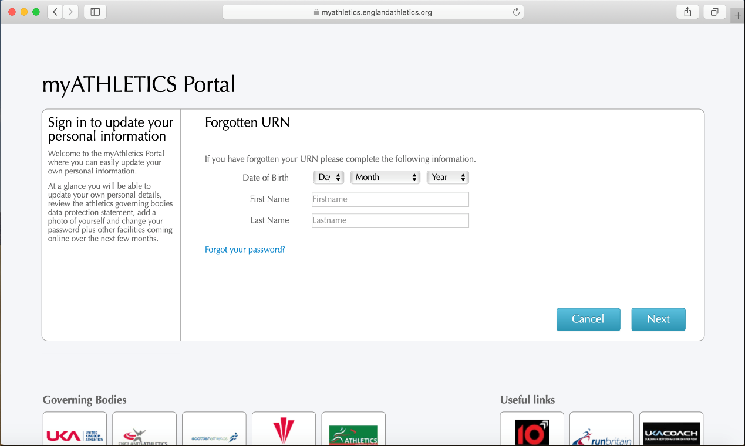

- Enter your postcode and click ‘Next’

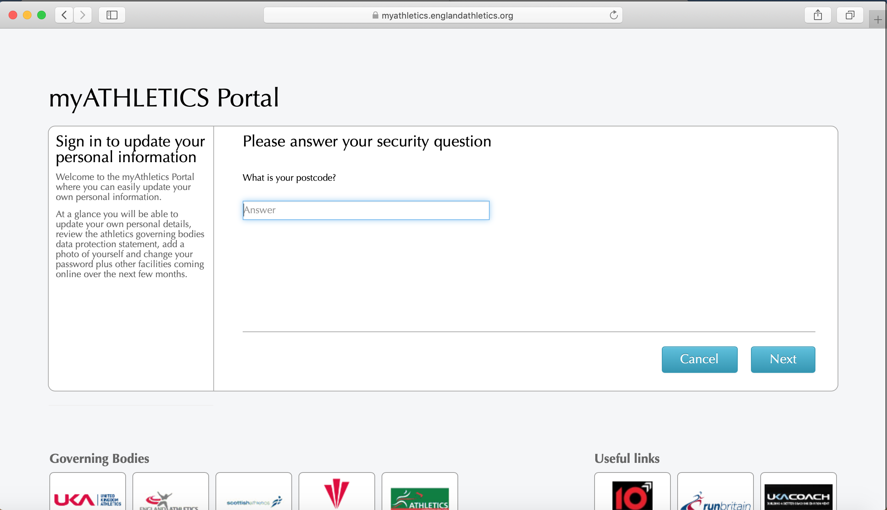

- Your URN will appear on the screen. An email confirming your URN will also be sent to the email address that we have registered for you

How to reset your Athletics Hub password

- Go to www.athleticshub.co.uk and click on the ‘Forgot your Password?’ link

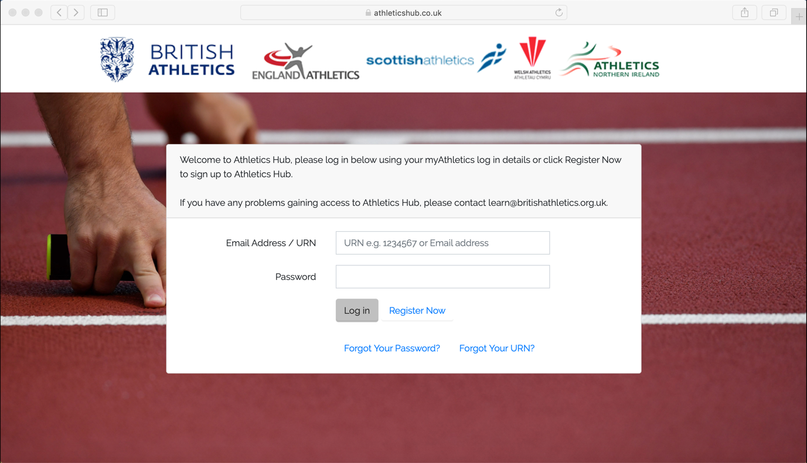

- Enter your URN or email address and click ‘Reset Password’

